PART – B 2.
import csv

# ---------------------------------------------------------
# a) Student Class
# ---------------------------------------------------------
class Student:
def __init__(self, rollno, name, grade):
self.rollno = rollno
self.name = name
self.grade = grade
def __repr__(self):
return f"Student(Roll: {self.rollno}, Name: {self.name}, Grade: {self.grade})"
# ---------------------------------------------------------
# b) Write and Read Operations
# ---------------------------------------------------------
def save_students_to_csv(filename, student_list):
"""Writes a list of Student objects to a CSV file."""
try:
with open(filename, mode='w', newline='') as file:
writer = csv.writer(file)
writer.writerow(["RollNo", "Name", "Grade"])
for student in student_list:
writer.writerow([student.rollno, student.name, student.grade])
print(f"SUCCESS: Saved {len(student_list)} students to '{filename}'.")
except IOError as e:
print(f"ERROR: Could not write to file. {e}")
def read_students_from_csv(filename):
students = []
try:
with open(filename, mode='r') as file:
reader = csv.reader(file)
next(reader)
for row in reader:
if row:
obj = Student(row[0], row[1], row[2])
students.append(obj)
return students
except FileNotFoundError:
print("ERROR: File not found.")
return []
# ---------------------------------------------------------
# c) Filter Functionality
# ---------------------------------------------------------
def filter_students(student_list, target_grade):
"""Filters students based on the provided grade."""
filtered_list = [s for s in student_list if s.grade == target_grade]
return filtered_list
# ---------------------------------------------------------
# Driver Code (Testing the Operations)
# ---------------------------------------------------------
if __name__ == "__main__":
data = [
Student(101, "Alice", "A"),
Student(102, "Bob", "B"),
Student(103, "Charlie", "A"),
Student(104, "David", "C")
]
filename = "students.csv"
modified_filename = "students_filtered.csv"
print("--- WRITING DATA ---")
save_students_to_csv(filename, data)
print("\n--- READING DATA ---")
loaded_students = read_students_from_csv(filename)
for s in loaded_students:
print(s)
print("\n--- FILTERING DATA (Grade = 'A') ---")
grade_a_students = filter_students(loaded_students, "A")
for s in grade_a_students:
print(s)
print("\n--- SAVING MODIFIED DATA ---")
save_students_to_csv(modified_filename, grade_a_students)

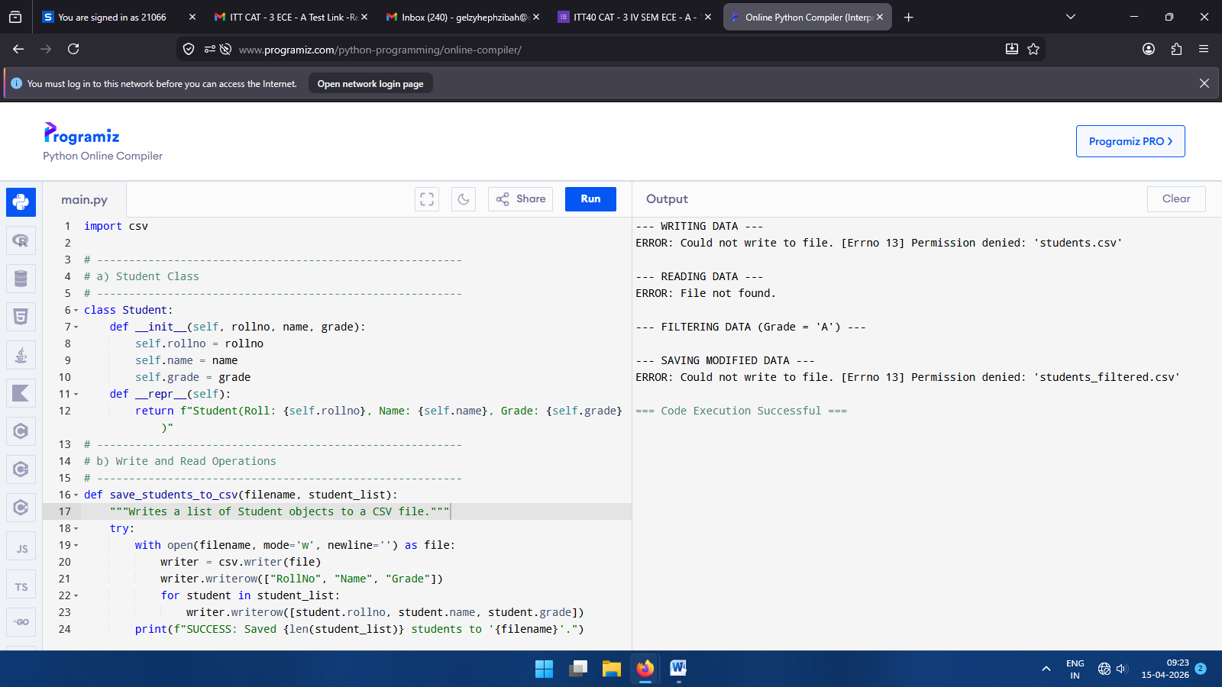

OUTPUT OF PART-B-2.

PART-B-1.

# ---------------------------------------------------------
# 1. Custom Exception Definitions
# ---------------------------------------------------------
class BankError(Exception):
pass

class AccountInactiveError(BankError):
pass

class InsufficientFundsError(BankError):
pass

class DailyLimitExceededError(BankError):
pass

class AccountNotFoundError(BankError):
pass
# ---------------------------------------------------------
# 2. BankAccount Class
# ---------------------------------------------------------
class BankAccount:
def __init__(self, name, balance=0.0, is_active=True):
self.name = name
self.balance = float(balance)
self.is_active = is_active
self.daily_withdrawn = 0.0
self.DAILY_LIMIT = 5000.0 # Example limit

def deposit(self, amount):
try:
# Check 1: Assertion for Input Validation
assert amount > 0, f"Deposit amount ({amount}) must be positive."

# Check 2: Exception for Account Status
if not self.is_active:
raise AccountInactiveError(f"Cannot deposit to inactive account: {self.name}")

self.balance += amount
print(f"SUCCESS: Deposited ${amount}. New Balance: ${self.balance}")

except AssertionError as ae:
print(f"ERROR (Assertion): {ae}")
except AccountInactiveError as e:
print(f"ERROR (Transaction Failed): {e}")

def withdraw(self, amount):
try:
# Check 1: Assertion for Input Validation
assert amount > 0, f"Withdrawal amount ({amount}) must be positive."

# Check 2: Exception for Business Logic
if amount > self.balance:
raise InsufficientFundsError(f"Insufficient funds. Balance: ${self.balance}, Requested: ${amount}")

if (self.daily_withdrawn + amount) > self.DAILY_LIMIT:
raise DailyLimitExceededError(f"Daily limit of ${self.DAILY_LIMIT} exceeded.")

self.balance -= amount
self.daily_withdrawn += amount
print(f"SUCCESS: Withdrew ${amount}. New Balance: ${self.balance}")

except AssertionError as ae:
print(f"ERROR (Assertion): {ae}")
except (InsufficientFundsError, DailyLimitExceededError) as e:
print(f"ERROR (Transaction Failed): {e}")

def transfer(self, target_account, amount):
try:
# Check 1: Assertion for Input Validation
assert amount > 0, f"Transfer amount ({amount}) must be positive."

# Check 2: Validate Destination Account
if target_account is None or not isinstance(target_account, BankAccount) or not target_account.is_active:
raise AccountNotFoundError("Destination account does not exist or is inactive.")

# Check 3: Check Source Balance (Reusing Exception logic)
if amount > self.balance:
raise InsufficientFundsError("Cannot transfer: Insufficient funds.")

# Execute Transfer (Atomic simulation)
self.balance -= amount
target_account.balance += amount
print(f"SUCCESS: Transferred ${amount} to {target_account.name}. Your Balance: ${self.balance}")

except AssertionError as ae:
print(f"ERROR (Assertion): {ae}")
except (AccountNotFoundError, InsufficientFundsError) as e:
print(f"ERROR (Transaction Failed): {e}")

# ---------------------------------------------------------
# 3. Driver Code (Testing the Scenarios)
# ---------------------------------------------------------
if __name__ == "__main__":
# Create Accounts
user = BankAccount("Alice", balance=1000, is_active=True)
closed_acc = BankAccount("Bob", balance=500, is_active=False)

print("--- SCENARIO A: Deposit Tests ---")
user.deposit(-500) # Fails: Assertion (Negative amount)
closed_acc.deposit(100) # Fails: Exception (Inactive account)
user.deposit(500) # Success

print("\n--- SCENARIO B: Withdrawal Tests ---")
user.withdraw(-100) # Fails: Assertion (Negative amount)
user.withdraw(50000) # Fails: Exception (Insufficient funds)
user.withdraw(6000) # Fails: Exception (Daily limit is 5000)
user.withdraw(200) # Success

print("\n--- SCENARIO C: Transfer Tests ---")
user.transfer(None, 100) # Fails: Exception (Account doesn't exist)
user.transfer(closed_acc, 100) # Fails: Exception (Target inactive)
user.transfer(user, -50) # Fails: Assertion (Negative amount)

# Valid transfer helper (Target must be active)
active_friend = BankAccount("Charlie", balance=0, is_active=True)
user.transfer(active_friend, 300) # Success

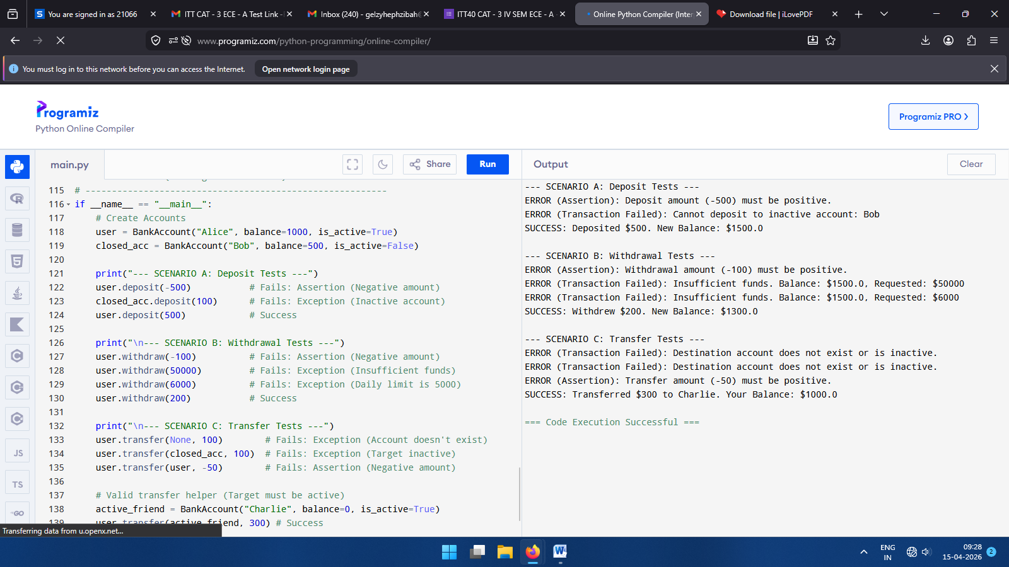

OUTPUT OF PARTB-1.

